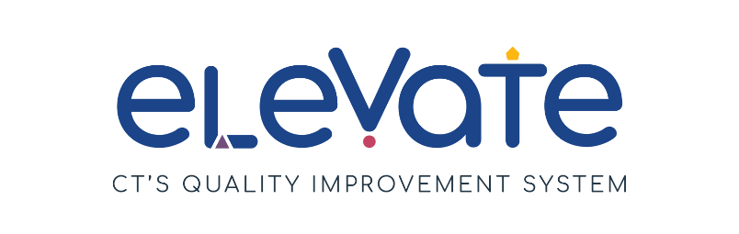

**Program Professional Development Plan (PPDP) Checklist**

**Description:**

Program Professional Development Plans support professional growth for the entire program and for individuals. A PPDP describes policies and procedures your program has in place to ensure that educators are well prepared to implement your curriculum and provide great care. These documents reference plans for hiring, for staff retention, and to improve teaching staff’s credentials and competencies. Most programs already have many elements of a PPDP. Putting that information together in one place can help you increase the quality of your program.

**Directions:**

Use this checklist to reflect on your professional growth plans. After completing the checklist, reflect on your responses to identify your priorities to help your program grow. Service Navigators can help connect you to OEC resources and help you choose your next step.

**Read about professional development planning in one program:**

Juanita is the director of Panda Preschool. She created an onboarding system to train new staff. She also has training to keep her current staff engaged and growing. This week, Juanita is onboarding Joanna to the program. Joanna is a lead educator because she has a Bachelor’s degree in Early Childhood Education. Joanna’s onboarding includes training on licensing requirements, program policies, and the curriculum they use Panda Preschool. The training will include information on Joanna’s specific job responsibilities from her job description.

Juanita is also working with Ricky, another educator, on his professional development goals for the year. Through a reflective conversation, Juanita and Ricky decide that he would like to learn more about child assessment. He would also like to add more dramatic play options to his classroom. Together, they make a list of professional development opportunities and readings for Ricky. Juanita plans to meet again with Ricky in 3 months to see if the plan is working to help Ricky meet his goals.

**Key Terms:**

In this checklist, we use some terms that may be new to you.

**Plan:** A plan is a written document that includes timelines, activities, and personnel involved in the proposed activities, as well as a system for documenting its completion.

**Competencies:** A “competency” is something you need to be able to do well in a specific job role. A competency reflects a person’s knowledge, skill, ability, and consistent behavior. Competencies come from formal education and practical experience.

**Orientation and Onboarding:** When a staff person is newly hired, *Orientation* is necessary for completing paperwork, setting expectations of what a new hire will be doing, and providing them with the tools to do it properly. *Onboarding* is a longer process that provides on-the-job training by management and other employees. Onboarding supports the new hire as they become familiar with the program’s culture and values and can last up to 12 months.

|  |  |  |  |  |
| --- | --- | --- | --- | --- |
| **Important Elements of a Program Professional Development Plan** | | | | |
|  | **We’ve got this!** | **We’re a work in progress!** | **We’re not there yet!** | **Comments** |
| **Does your PPDP include:** | | | | |
| Written job descriptions for each staff position that include job duties, education requirements, competencies, salary, benefits, physical requirements, and desired personal qualities. Job descriptions should also address Connecticut Licensing requirements including: minimum age for staff, health evaluation, criminal background check, and state child abuse registry check. Additional requirements may include, first aid/CPR, and/or medication administration training. |  |  |  |  |
| Written plan for orientation / onboarding process for new staff. This may include: list of orientation topics (curriculum, discipline policy, program routines, key regulations, families served), plan for addressing orientation topics, observations, coaching and mentoring experiences, probationary period. |  |  |  |  |
| A list of the qualifications of each of your educators, identifying where competencies are strong across the team, and areas to target for improvement. This list should include number of lead teachers with BAs and AAs in ECE (or equivalent); number of teaching assistants with CDAs (or equivalent); number of teachers competent in child assessment practices; staff trained to coach or mentor others; bilingual staff. |  |  |  |  |
| List of expectations for staff key competencies. This may include child development knowledge, CT CKC, classroom management, curriculum planning, child assessment, equity practices, communication and collaboration skills. |  |  |  |  |
| Detailed plan to align current staff competencies with expected staff competencies, detailed above. How will you get your staff where you want them to be? This plan may include colleges, certification organizations, online education, continuing education providers, training conferences, in-service training |  |  |  |  |

Choose one thing you would like to improve. What will the benefits to implementing this be to your staff and your program?